**TASK 3- Minikube Depolyement Task**

**Step 1:**

Start the minikube cluster using the command:

minikube start

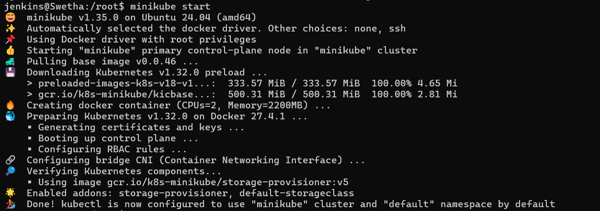

This initializes the Minikube cluster using Docker as the driver.

**Step 2: Install kubectl**

sudo snap install kubectl --classic

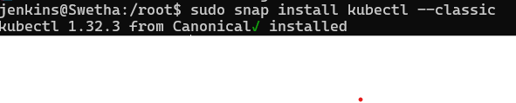

**Step 3: Verify kubectl Installation**

Kubectl version 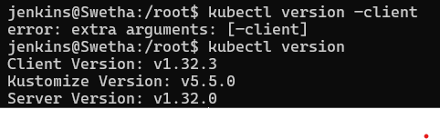

**Step 4: Create a deployement**

kubectl create deployment r2 --image=swethamurugesan/devopsgit --port=80

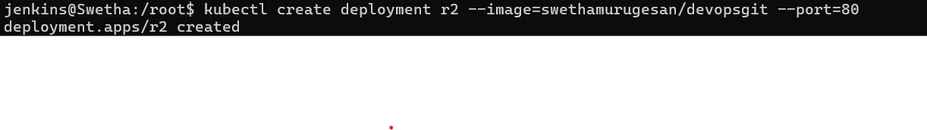

**Step 5: Expose the document**

kubectl expose deployment r2 --port=80 --type=NodePort

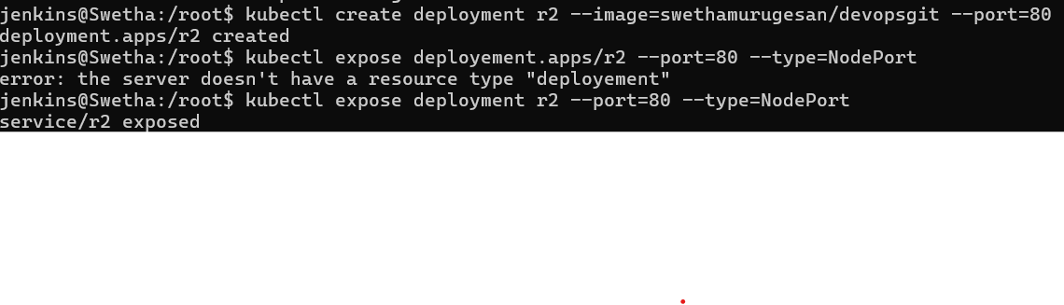

**Step 6:Access the service**

minikube service r2

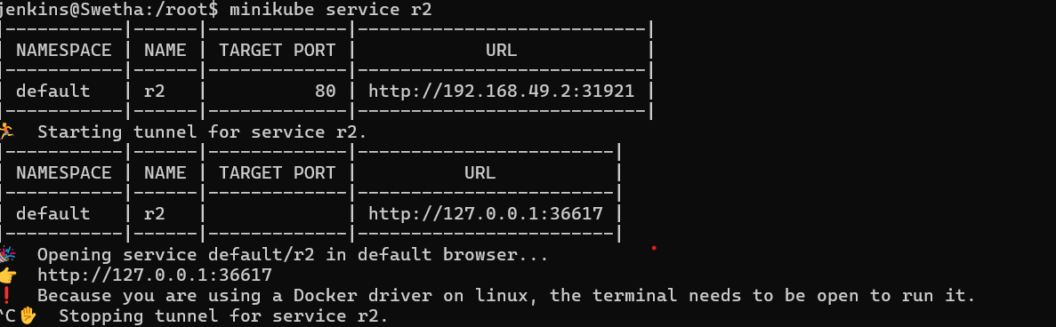

**Step 7: Output in Browser**

